[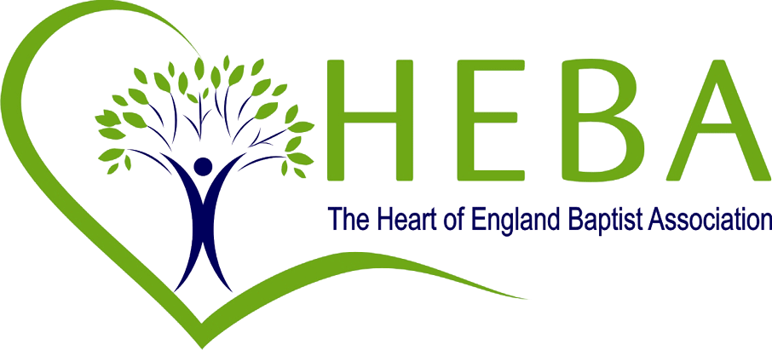](http://www.baptist-heartofengland.org/)

HEART OF ENGLAND BAPTIST ASSOCIATION

RECRUITMENT INFORMATION

AND

ROLE PROFILE FOR REGIONAL MINISTER

July 2025

Context

Who we are

The Heart of England Baptist Association (HEBA) brings together 152 churches in Herefordshire, Shropshire, Staffordshire, the Black Country, Birmingham, Coventry, Warwickshire and Worcestershire, with an office in Sutton Coldfield.

What we are about

Reflecting the words used by the BUGB, our purpose is to grow healthy churches – stimulating and assisting the region’s Baptist churches for their God-given task of sharing the good news of Jesus Christ.

What drives us

We are driven by the pursuit of five values we wish to see exhibited across the Association as we engage in God’s mission:

**Companionship**

Walking with and watching over each other is the very definition of associating. The regional team make the care of ministers and churches their first priority. Ministers are connected and accountable to each other, while churches are committed to building relationships with each other and to living empathetically in their locality. The regional team and trustees are determined to be similarly approachable and supportive in their working together.

**Generosity**

A heart and spirit of generosity is encouraged throughout HEBA. We look for reasons to say ‘yes’ to working in partnership with each other, whether through advice or support offered by the regional team; project funding given by the grants group; resources shared between one church and another; or the serving of the local community by each HEBA church. Generosity makes a priority of those with less so that there is equality of opportunity for all those seeking to join God’s mission.

**Diversity**

We share a common purpose in growing God’s kingdom, yet celebrate the reality that in Christ we are a diverse mix of people, communities, context and approach. We respectfully explore our diversity in ethnicity and culture; in theological position and style of worship; in age profile and size of congregation. When we disagree, we do not allow difference to stand in the way of grace and mercy.

**Learning**

We further our understanding of God and his heart for our world by encouraging dialogue, study and reflection among our ministers, regional team and churches that nurtures and provokes spiritual growth and development. We challenge any barriers to learning, whatever their basis. We encourage and facilitate continued ministerial development for all ministers.

**Innovation**

Contemporary culture demands a broad and imaginative approach to ministry and mission. We encourage and facilitate churches and ministers to seek and follow the leading of the Holy Spirit into new ways of being church, and towards creativity in their sharing of Jesus’ love.

**Our Team**

The HEBA staff team comprise Regional Minister Team Leader (RMTL), Regional Minister, Administrator, Admin/Communications Officer, Safeguarding Officer, Finance Manager and Bookkeeper. The team is supported by a board of Trustees/Directors, a number of working groups, and volunteers. The Association also employed a third Regional Minister who retired recently.

**Increasing Capacity and Diversity**

The HEBA trustees are looking to enhance the current team by appointing a third Regional Minister on a part-time (50%) basis to serve for two years from autumn 2025. This is a transitional role, which will increase the capacity and diversity of the RM team and take forward the implementation of the Project Violet recommendations.

**HEBA REGIONAL MINISTER**

**Job Title** Regional Minister (0.5FTE)

**Responsible to** HEBA Regional Minister Team Leader

**Key responsibilities**  Pastoral care of ministers and churches in a particular area and Project Violet lead for the Association

**Remuneration** 1.2 BUGB Stipend (Standard Terms of Appointment, pro rata)

**Duration of role** Two years from appointment

**General Overview**

* General duties of a Regional Minister – working collaboratively with other team members to support churches and ministers, with responsibility for providing pastoral care and encouragement within a defined geographical area.
* Inspire, encourage and equip leaders, ministers and churches in mission focussed ministry Encourage and facilitate local minister gatherings to encourage interdependence and provide peer support.
* Be an active part of a flexible team by undertaking ministry opportunities, alongside or in place of other team members, and collaborating with colleagues to develop vision and implementation agreed strategies which focus on HEBA priorities.
* Oversee the implementation of the Project Violet recommendations.
* Ensuring representation in local ecumenical networks as agreed with the RMTL.

**Specifically**

1. Delivering pastoral care of ministers and churches in a particular area
   1. Regular and frequent contact with ministers and pastoral leaders.
   2. The encouragement and appropriate support of ministers and their families.
   3. The encouragement and appropriate support of retired ministers and their families.
   4. Preaching, teaching and leading worship on a regular basis.
   5. Providing support to the Pastoral Ministers in a defined geographical area.
2. **Providing guidance for churches through the settlement process**
3. **Giving guidance and support through the recognition and accreditation processes:**
   1. Counsel for testing a call to ministry
   2. Guidance through the recognition process, including counsel during the settlement period
4. **Encouraging mission in the churches**
5. **Collaborate with colleagues to develop vision and implement agreed strategies which focus on HEBA priorities.**
6. **Supporting the other Regional Ministers in their areas as required**
7. **Supporting the development of ministers’ gatherings**
8. **Supporting and encouraging churches with no minister or pastor**
9. **Participating in Associations Groups as necessary**
10. **Promotion of Home Mission**
11. **Ensuring representation in local ecumenical networks as agreed with the RMTL**
12. **Represent HEBA in Baptist gatherings as agreed with the RMTL**

**Core Competencies and Skills (Person Profile)**

|  |  |  |
| --- | --- | --- |
|  | Essential | Desirable |
|  | | |
| Personal Qualities | An accredited minister of BUGB who is able to demonstrate a mature and fruitful faith |  |
|  | A person of deep conviction, able to work collaboratively and harmoniously, with strong characters when needed |  |
|  | Excellent interpersonal and team skills |  |
|  | A gifted relationship builder, self-aware, capable of holding the trust of regional and local leaders |  |
|  | A good timekeeper, able to manage workloads whilst working to a consistently high standard |  |
|  | Excellent communicator, in both oral and written forms |  |
|  | Capacity to be flexible when required alongside being able to maintain a healthy work-life balance |  |
|  | A Person who inspires and encourages others (diplomatic, personable etc). |  |
| Education | Theologically qualified to diploma in Theology level | Theological degree or above |
| Training/mentoring | Evidence of developing effective training/mentoring in the local church that has resulted in positive change and growth | Previous experience of arranging and enabling effective and inspirational training events for groups of ministers, leaders and churches |
|  | Evidence of commitment to CMD and able to promote CMD effectively |  |
| Mission Skills | Experience of partnership with people from a wide breadth of Christian traditions | Able to provide evidence of leading effective mission and evangelism work |
|  | Understanding of Home Mission |  |
|  | Significant experience of pastoring a Baptist Church |  |
|  | Evidence and recognition of ministry beyond one’s own church. |  |
| Management, organisation and people leadership | Ability to support volunteers e.g. pastoral ministers |  |
|  | Ability to engage with conflict and help find resolutions | A creative, strategic and critical thinker |
|  |  | Able to regularly set priorities and goals, then wisely deploy people and resources to work towards those ends |
| IT/Admin/Other | Competent in use of computers/IT | Use of social media in communications |
|  | Good admin and organisational skills |  |
|  | Ability to provide evidence of Energy and enthusiasm for the Association and Baptist Family |  |
|  | Enhanced DBS check with barred list will be required at the point of appointment |  |

**How to apply:**

Please send a letter of application with a CV and the names of two referees to

Karen A Martindale, Association Administrator

[km@baptist-heartofengland.org](mailto:km@baptist-heartofengland.org) by **19th August 2025**

References will only be taken up following the interview process.

**Interviews will be held 8th September 2025.**

Information pack can be downloaded from the website.

<https://www.baptist-heartofengland.org/Groups/431111/Work_with_us.aspx>

For further information please contact Karen Martindale.

KAM 16.07.2025 v6